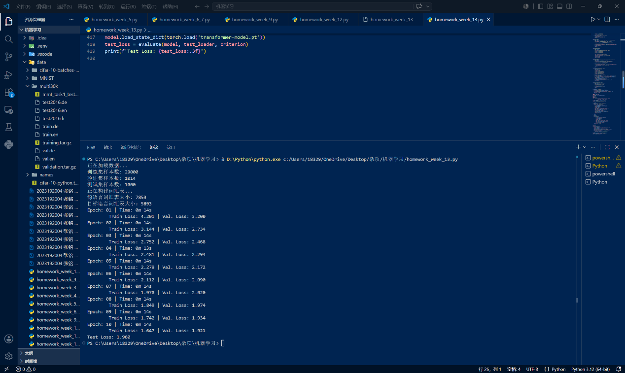
import torch
import torch.nn as nn
import torch.optim as optim
from torch.utils.data import Dataset, DataLoader
from torch.nn.utils.rnn import pad_sequence
from collections import Counter
import spacy
import random
import math
import time
import os

# 设置随机种子
SEED = 1234
random.seed(SEED)
torch.manual_seed(SEED)
torch.backends.cudnn.deterministic = True

# 1. 数据预处理 - 使用 spaCy 进行分词
spacy_de = spacy.load('de_core_news_sm')
spacy_en = spacy.load('en_core_web_sm')

def tokenize_de(text):
return [tok.text.lower() for tok in spacy_de.tokenizer(text)]

def tokenize_en(text):
return [tok.text.lower() for tok in spacy_en.tokenizer(text)]

# 特殊符号定义
SPECIAL_SYMBOLS = ['<pad>', '<sos>', '<eos>', '<unk>']
PAD_IDX = 0
SOS_IDX = 1
EOS_IDX = 2
UNK_IDX = 3

# 自定义 Dataset 类
class TranslationDataset(Dataset):
"""从本地文件加载翻译数据集"""

def __init__(self, src_file, trg_file, src_tokenizer, trg_tokenizer):
self.src_sentences = []
self.trg_sentences = []
with open(src_file, 'r', encoding='utf-8') as f_src, \
open(trg_file, 'r', encoding='utf-8') as f_trg:
for src_line, trg_line in zip(f_src, f_trg):
src_line = src_line.strip()
trg_line = trg_line.strip()
if src_line and trg_line:
self.src_sentences.append(src_tokenizer(src_line))
self.trg_sentences.append(trg_tokenizer(trg_line))

def __len__(self):
return len(self.src_sentences)

def __getitem__(self, idx):
return self.src_sentences[idx], self.trg_sentences[idx]

# 构建词汇表
def build_vocab(data_iter, specials, max_size=10000, min_freq=2):
"""从数据集构建词汇表"""
counter = Counter()
for tokens in data_iter:
counter.update(tokens)
# 按频率排序，保留高频词
most_common = counter.most_common(max_size - len(specials))
# 过滤掉低频词
vocab_list = [word for word, freq in most_common if freq >= min_freq]
# 构建 stoi 和 itos 映射
stoi = {sym: i for i, sym in enumerate(specials)}
itos = list(specials)
for word in vocab_list:
stoi[word] = len(itos)
itos.append(word)
return stoi, itos

def yield_tokens(dataset, lang_idx):
"""生成 tokens 迭代器"""
for i in range(len(dataset)):
src, trg = dataset[i]
yield src if lang_idx == 0 else trg

def numericalize(vocab_stoi, tokens):
"""将 token 序列转换为索引序列（带 <sos> 和 <eos>）"""
return [SOS_IDX] + [vocab_stoi.get(t, UNK_IDX) for t in tokens] + [EOS_IDX]

# 2. 设置数据目录并加载数据
DATA_DIR = "./data/multi30k"

print("正在加载数据...")
train_dataset = TranslationDataset(
os.path.join(DATA_DIR, 'train.de'),
os.path.join(DATA_DIR, 'train.en'),
tokenize_de, tokenize_en
)
valid_dataset = TranslationDataset(
os.path.join(DATA_DIR, 'val.de'),
os.path.join(DATA_DIR, 'val.en'),
tokenize_de, tokenize_en
)
test_dataset = TranslationDataset(
os.path.join(DATA_DIR, 'test2016.de'),
os.path.join(DATA_DIR, 'test2016.en'),
tokenize_de, tokenize_en
)
print(f"训练集样本数: {len(train_dataset)}")
print(f"验证集样本数: {len(valid_dataset)}")
print(f"测试集样本数: {len(test_dataset)}")

# 构建词汇表
print("正在构建词汇表...")
src_stoi, src_itos = build_vocab(
yield_tokens(train_dataset, 0),
specials=SPECIAL_SYMBOLS,
max_size=10000,
min_freq=2
)
trg_stoi, trg_itos = build_vocab(
yield_tokens(train_dataset, 1),
specials=SPECIAL_SYMBOLS,
max_size=10000,
min_freq=2
)
print(f"源语言词汇表大小: {len(src_stoi)}")
print(f"目标语言词汇表大小: {len(trg_stoi)}")

# 自定义 collate 函数（用于 DataLoader 的批处理填充）
def collate_fn(batch):
src_batch, trg_batch = [], []
for src_tokens, trg_tokens in batch:
src_batch.append(torch.tensor(numericalize(src_stoi, src_tokens), dtype=torch.long))
trg_batch.append(torch.tensor(numericalize(trg_stoi, trg_tokens), dtype=torch.long))
# pad_sequence 默认 batch_first=False → 形状 [seq_len, batch_size]
src_batch = pad_sequence(src_batch, padding_value=PAD_IDX)
trg_batch = pad_sequence(trg_batch, padding_value=PAD_IDX)
return src_batch, trg_batch

# 创建 DataLoader（替代旧的 BucketIterator）
device = torch.device('cuda' if torch.cuda.is_available() else 'cpu')
BATCH_SIZE = 128

train_loader = DataLoader(
train_dataset, batch_size=BATCH_SIZE, shuffle=True,
collate_fn=collate_fn, drop_last=True
)
valid_loader = DataLoader(
valid_dataset, batch_size=BATCH_SIZE, shuffle=False,
collate_fn=collate_fn, drop_last=True
)
test_loader = DataLoader(
test_dataset, batch_size=BATCH_SIZE, shuffle=False,
collate_fn=collate_fn, drop_last=True
)

# 2. 模型定义（完全遵循论文架构）
class Transformer(nn.Module):
def __init__(self,
input_dim,
output_dim,
hid_dim=512,
n_layers=6,
n_heads=8,
pf_dim=2048,
dropout=0.1,
max_length=100):
super().__init__()
self.encoder = Encoder(input_dim, hid_dim, n_layers, n_heads, pf_dim, dropout,
max_length)
self.decoder = Decoder(output_dim, hid_dim, n_layers, n_heads, pf_dim, dropout,
max_length)
self.out = nn.Linear(hid_dim, output_dim)
self.dropout = nn.Dropout(dropout)

def forward(self, src, trg, src_mask, trg_mask):
enc_src = self.encoder(src, src_mask)
output = self.decoder(trg, enc_src, trg_mask, src_mask)
return self.out(output)

# 位置编码（正弦/余弦）
class PositionalEncoding(nn.Module):
def __init__(self, hid_dim, dropout, max_length=100):
super().__init__()
self.dropout = nn.Dropout(dropout)
pe = torch.zeros(max_length, hid_dim)
position = torch.arange(0, max_length).unsqueeze(1)
div_term = torch.exp(torch.arange(0, hid_dim, 2) * (-math.log(10000.0) / hid_dim))
pe[:, 0::2] = torch.sin(position * div_term)
pe[:, 1::2] = torch.cos(position * div_term)
pe = pe.unsqueeze(0)
self.register_buffer('pe', pe)

def forward(self, x):
x = x + self.pe[:, :x.size(1)]
return self.dropout(x)

# 编码器层
class EncoderLayer(nn.Module):
def __init__(self, hid_dim, n_heads, pf_dim, dropout):
super().__init__()
self.self_attn = MultiHeadAttention(hid_dim, n_heads, dropout)
self.pwff = PositionwiseFeedforward(hid_dim, pf_dim, dropout)
self.norm1 = nn.LayerNorm(hid_dim)
self.norm2 = nn.LayerNorm(hid_dim)
self.dropout = nn.Dropout(dropout)

def forward(self, src, src_mask):
_src, _ = self.self_attn(src, src, src, src_mask)
src = self.norm1(src + self.dropout(_src))
_src = self.pwff(src)
src = self.norm2(src + self.dropout(_src))
return src

# 编码器
class Encoder(nn.Module):
def __init__(self, input_dim, hid_dim, n_layers, n_heads, pf_dim, dropout, max_length):
super().__init__()
self.tok_embedding = nn.Embedding(input_dim, hid_dim)
self.pos_embedding = PositionalEncoding(hid_dim, dropout, max_length)
self.layers = nn.ModuleList([EncoderLayer(hid_dim, n_heads, pf_dim, dropout)
for _ in range(n_layers)])
self.dropout = nn.Dropout(dropout)

def forward(self, src, src_mask):
src = self.dropout(self.tok_embedding(src) * math.sqrt(self.tok_embedding.embedding_dim))
src = self.pos_embedding(src)
for layer in self.layers:
src = layer(src, src_mask)
return src

# 解码器层
class DecoderLayer(nn.Module):
def __init__(self, hid_dim, n_heads, pf_dim, dropout):
super().__init__()
self.self_attn = MultiHeadAttention(hid_dim, n_heads, dropout)
self.enc_attn = MultiHeadAttention(hid_dim, n_heads, dropout)
self.pwff = PositionwiseFeedforward(hid_dim, pf_dim, dropout)
self.norm1 = nn.LayerNorm(hid_dim)
self.norm2 = nn.LayerNorm(hid_dim)
self.norm3 = nn.LayerNorm(hid_dim)
self.dropout = nn.Dropout(dropout)

def forward(self, trg, enc_src, trg_mask, src_mask):
_trg, _ = self.self_attn(trg, trg, trg, trg_mask)
trg = self.norm1(trg + self.dropout(_trg))
_trg, attention = self.enc_attn(trg, enc_src, enc_src, src_mask)
trg = self.norm2(trg + self.dropout(_trg))
_trg = self.pwff(trg)
trg = self.norm3(trg + self.dropout(_trg))
return trg, attention

# 解码器
class Decoder(nn.Module):
def __init__(self, output_dim, hid_dim, n_layers, n_heads, pf_dim, dropout, max_length):
super().__init__()
self.tok_embedding = nn.Embedding(output_dim, hid_dim)
self.pos_embedding = PositionalEncoding(hid_dim, dropout, max_length)
self.layers = nn.ModuleList([DecoderLayer(hid_dim, n_heads, pf_dim, dropout)
for _ in range(n_layers)])
self.dropout = nn.Dropout(dropout)

def forward(self, trg, enc_src, trg_mask, src_mask):
trg = self.dropout(self.tok_embedding(trg) * math.sqrt(self.tok_embedding.embedding_dim))
trg = self.pos_embedding(trg)
for layer in self.layers:
trg, attention = layer(trg, enc_src, trg_mask, src_mask)
return trg

# 多头注意力
class MultiHeadAttention(nn.Module):
def __init__(self, hid_dim, n_heads, dropout):
super().__init__()
assert hid_dim % n_heads == 0
self.hid_dim = hid_dim
self.n_heads = n_heads
self.head_dim = hid_dim // n_heads
self.fc_q = nn.Linear(hid_dim, hid_dim)
self.fc_k = nn.Linear(hid_dim, hid_dim)
self.fc_v = nn.Linear(hid_dim, hid_dim)
self.fc_o = nn.Linear(hid_dim, hid_dim)
self.dropout = nn.Dropout(dropout)
self.scale = math.sqrt(self.head_dim)

def forward(self, query, key, value, mask=None):
batch_size = query.shape[0]
Q = self.fc_q(query).view(batch_size, -1, self.n_heads, self.head_dim).transpose(1, 2)
K = self.fc_k(key).view(batch_size, -1, self.n_heads, self.head_dim).transpose(1, 2)
V = self.fc_v(value).view(batch_size, -1, self.n_heads, self.head_dim).transpose(1, 2)
energy = torch.matmul(Q, K.transpose(-2, -1)) / self.scale
if mask is not None:
energy = energy.masked_fill(mask == 0, -1e10)
attention = torch.softmax(energy, dim=-1)
x = torch.matmul(self.dropout(attention), V)
x = x.transpose(1, 2).contiguous().view(batch_size, -1, self.hid_dim)
x = self.fc_o(x)
return x, attention

# 前馈网络
class PositionwiseFeedforward(nn.Module):
def __init__(self, hid_dim, pf_dim, dropout):
super().__init__()
self.fc1 = nn.Linear(hid_dim, pf_dim)
self.fc2 = nn.Linear(pf_dim, hid_dim)
self.dropout = nn.Dropout(dropout)

def forward(self, x):
x = self.dropout(torch.relu(self.fc1(x)))
x = self.fc2(x)
return x

# 3. 掩码生成
def create_mask(src, trg, pad_idx):
src_mask = (src != pad_idx).unsqueeze(1).unsqueeze(2)
trg_pad_mask = (trg != pad_idx).unsqueeze(1).unsqueeze(3)
trg_len = trg.shape[1]
trg_sub_mask = torch.tril(torch.ones((trg_len, trg_len), device=device)).bool()
trg_mask = trg_pad_mask & trg_sub_mask
return src_mask, trg_mask

# 4. 初始化模型
INPUT_DIM = len(src_stoi)
OUTPUT_DIM = len(trg_stoi)
HID_DIM = 256 # 论文中为512，此处减小以加快训练
N_LAYERS = 3 # 论文中为6，此处减小
N_HEADS = 8
PF_DIM = 512
DROPOUT = 0.1
MAX_LENGTH = 100

model = Transformer(INPUT_DIM, OUTPUT_DIM, HID_DIM, N_LAYERS, N_HEADS,
PF_DIM, DROPOUT, MAX_LENGTH).to(device)

# 5. 优化器与损失函数
optimizer = optim.Adam(model.parameters(), lr=0.0005)
criterion = nn.CrossEntropyLoss(ignore_index=PAD_IDX)

# 6. 训练函数
def train(model, loader, optimizer, criterion, clip):
model.train()
epoch_loss = 0
for i, (src, trg) in enumerate(loader):
src, trg = src.to(device), trg.to(device)
src = src.transpose(0, 1) # [batch_size, src_len]
trg = trg.transpose(0, 1) # [batch_size, trg_len]
optimizer.zero_grad()
trg_input = trg[:, :-1]
trg_output = trg[:, 1:]
src_mask, trg_mask = create_mask(src, trg_input, PAD_IDX)
output = model(src, trg_input, src_mask, trg_mask)
output_dim = output.shape[-1]
output = output.contiguous().view(-1, output_dim)
trg_output = trg_output.contiguous().view(-1)
loss = criterion(output, trg_output)
loss.backward()
torch.nn.utils.clip_grad_norm_(model.parameters(), clip)
optimizer.step()
epoch_loss += loss.item()
return epoch_loss / len(loader)

# 7. 评估函数
def evaluate(model, loader, criterion):
model.eval()
epoch_loss = 0
with torch.no_grad():
for src, trg in loader:
src, trg = src.to(device), trg.to(device)
src = src.transpose(0, 1)
trg = trg.transpose(0, 1)
trg_input = trg[:, :-1]
trg_output = trg[:, 1:]
src_mask, trg_mask = create_mask(src, trg_input, PAD_IDX)
output = model(src, trg_input, src_mask, trg_mask)
output_dim = output.shape[-1]
output = output.contiguous().view(-1, output_dim)
trg_output = trg_output.contiguous().view(-1)
loss = criterion(output, trg_output)
epoch_loss += loss.item()
return epoch_loss / len(loader)

# 8. 训练循环
N_EPOCHS = 10
CLIP = 1
best_valid_loss = float('inf')
for epoch in range(N_EPOCHS):
start_time = time.time()
train_loss = train(model, train_loader, optimizer, criterion, CLIP)
valid_loss = evaluate(model, valid_loader, criterion)
end_time = time.time()
epoch_mins, epoch_secs = divmod(end_time - start_time, 60)
print(f'Epoch: {epoch+1:02} | Time: {epoch_mins:.0f}m {epoch_secs:.0f}s')
print(f'\tTrain Loss: {train_loss:.3f} | Val. Loss: {valid_loss:.3f}')
if valid_loss < best_valid_loss:
best_valid_loss = valid_loss
torch.save(model.state_dict(), 'transformer-model.pt')

# 9. 测试
model.load_state_dict(torch.load('transformer-model.pt'))
test_loss = evaluate(model, test_loader, criterion)
print(f'Test Loss: {test_loss:.3f}')

